Final Documentation of the Simulator

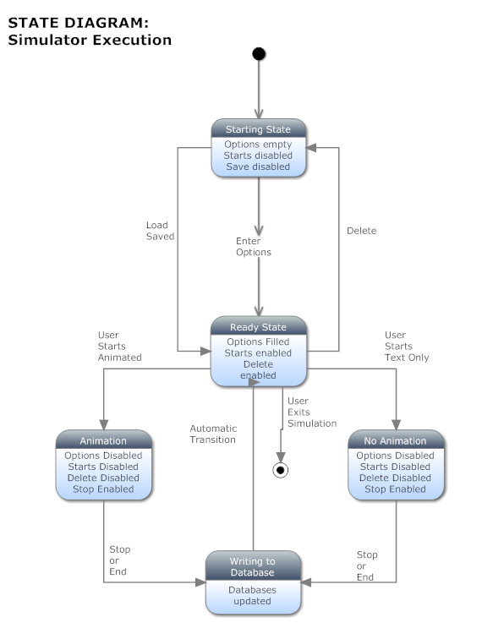

List and Description of Classes:

* WSNSimulation
  + Surrounding class holding the main method for the WSNFrame class
* WSNFrame
  + Holds all of the interface logic and construction for the simulator
* RunSim
  + Holds all of the general simulation running logic and SQLite functions
* RunNoAnimation
  + Uses the RunSim class to run a simulation without animating the WSN and intruder
* Surface
  + Uses the RunSim class to run a simulation and show the simulation on a JPanel in the simulator
* Mouse
  + Holds all of the information and functions pertaining to an intruder
* Cat
  + Holds all of the information and function pertaining to a sensor
* IntrusionAlgorithm
  + The interface class for all of the intrusion algorithms
  + Intrusion algorithm classes are given here
    - AStarIntrusion
      * Uses A\* to find a path
    - ChunkedAStarIntrusion
      * Uses A\* on a limited area to find a path
    - GoAround
      * When it detects a sensor, the intruder simply goes around it and keeps a log of sensors encountered to avoid infinite loops
    - FollowTheGap
      * Tries to split the angle between sensors
    - LinearAlgorithm
      * Goes forward only
    - RandomIntrusion
      * Randomly traverses the Field of Interest
* GraphSurface
  + A class that holds the logic for the second panel of the simulator which graphs data
  + This class was largely unused due to the ease of use of R with our data in SQLite